📄 AI-Based Diabetes Risk Prediction System with Interactive Dashboard and AI Assistant

Authors
Lakshya Kanodia
SAP ID: 590027644
Anushka Kholi
SAP ID: 590027851
Dhananjay Chaudhary
SAP ID: 590027130

Abstract
Diabetes is a prevalent chronic disease that requires early detection for effective management. This paper presents a machine learning–based system for predicting diabetes risk using clinical attributes. Multiple algorithms—Random Forest, Logistic Regression, Decision Tree, and K-Nearest Neighbors—are evaluated, with Random Forest selected as the primary model due to its superior performance. A web application built using Streamlit provides real-time predictions, interactive visualizations, and patient history tracking. An offline AI assistant is integrated to explain results and system features. Additionally, the system provides doctor recommendations and personalized precautionary guidance based on predicted risk levels. Experimental results show reliable accuracy and demonstrate the applicability of AI in healthcare decision support.

Keywords
Machine Learning, Diabetes Prediction, Random Forest, Streamlit, AI Assistant, Healthcare Analytics, Risk Assessment

1. Introduction
Diabetes affects millions globally and can lead to severe complications if not detected early. Conventional diagnosis requires laboratory testing and expert interpretation. With advances in Artificial Intelligence (AI), machine learning models can analyze patient data and predict disease risk efficiently.
This project proposes a system that:
- Predicts diabetes risk using ML models
- Compares multiple algorithms
- Visualizes data patterns
- Stores patient history
- Provides doctor advice and precautions
- Includes an AI assistant for user interaction

2. Literature Review
Prior work uses Logistic Regression, Decision Trees, SVMs, and ensemble methods for diabetes prediction. Ensemble methods such as Random Forest often outperform single models due to better generalization and robustness to noise.
This work extends existing approaches by adding:
- Interactive dashboard (Streamlit)
- Model comparison and confusion matrix
- AI assistant (offline)
- Actionable health recommendations (doctor advice + precautions)

3. Methodology

🧠 1. System Architecture (Core Idea)

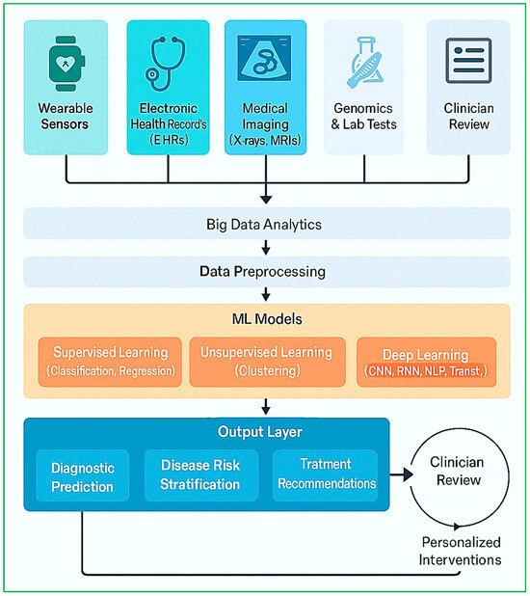
The system architecture represents the overall working of the diabetes prediction system. It starts with user input, which is processed and passed into a trained machine learning model. The model predicts the diabetes risk, and the output is displayed through a web interface. The system also includes visualization, AI assistant interaction, and patient history storage.

🧾 Key Points
- Input: Patient data (Glucose, BMI, Age, etc.)
- Processing: Data preprocessing
- Model: Random Forest prediction
- Output: Risk level + probability
- Extra: AI assistant + history storage

🔄 2. Workflow / Flowchart (How system works)

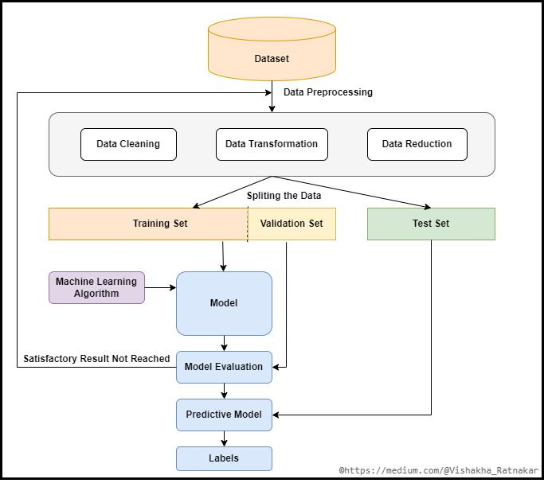
The workflow diagram explains step-by-step execution of the system. It begins with user input and moves through preprocessing, prediction, and output generation. After prediction, the system provides doctor recommendations and precautions and stores the data for future reference.

🧾 Steps
- Start
- Enter patient data
- Preprocess data
- Apply ML model
- Generate prediction
- Show result
- Give doctor advice
- Store history
- End

🩺 3. Health Recommendation System (Your BEST Feature 🔥)

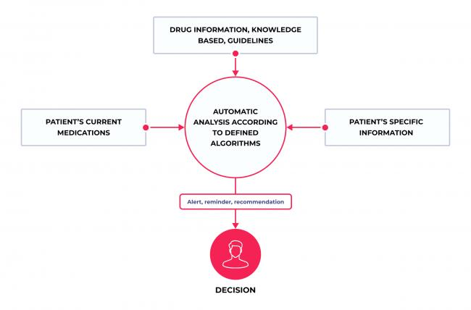
This is a key feature of the system. After predicting diabetes risk, the application provides personalized medical advice. If the risk is high, it recommends immediate consultation with a doctor and gives strict precautions. For medium and low risk, it suggests preventive measures and lifestyle improvements.

🧾 Logic Used
- High Risk → Immediate doctor consultation + strict precautions
- Medium Risk → Medical checkup + preventive care
- Low Risk → Healthy lifestyle maintenance

🧾 Example Advice
- Reduce sugar intake
- Exercise regularly
- Monitor glucose level
- Maintain proper diet
- Regular health checkups

📄 4. Implementation
The proposed system is implemented using Python and various machine learning and visualization libraries. A web-based interface is developed using Streamlit to provide an interactive and user-friendly experience. The implementation consists of data handling, model training, prediction, visualization, AI assistant integration, and a health recommendation system.

4.1 Technologies Used
The following tools and technologies are used:
- Python – Core programming language
- Streamlit – Web application framework
- Scikit-learn – Machine learning models
- Pandas & NumPy – Data processing
- Plotly – Data visualization
- Pyttsx3 – Voice assistant

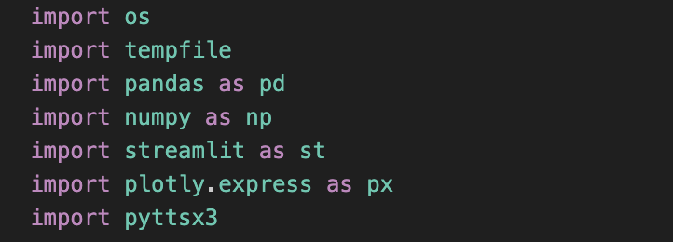

4.2 User Interface Implementation

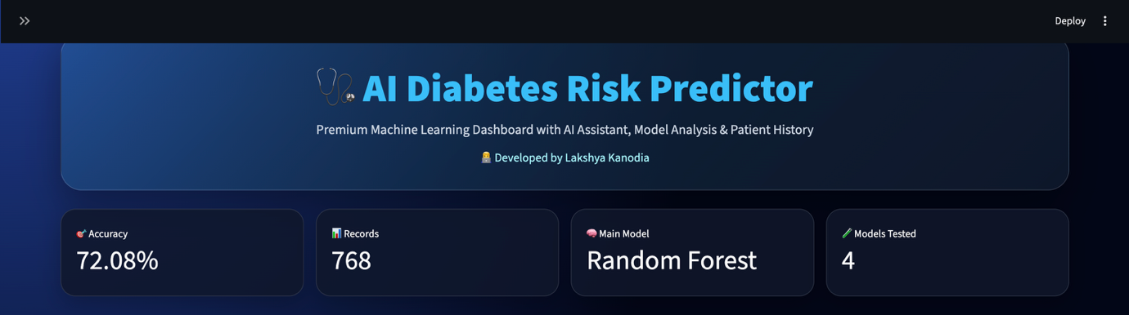
User Interface of the Diabetes Prediction System
The system provides a premium user interface developed using Streamlit. The dashboard includes model accuracy, dataset information, and multiple tabs for prediction, visualization, model analysis, and patient history. The design ensures ease of use and accessibility.

4.3 Prediction Module
The prediction module takes user input such as glucose level, BMI, age, and other medical parameters. These inputs are passed to the trained Random Forest model to predict diabetes risk.

📌 Key Features
- Real-time prediction
- Probability-based output
- Risk classification (Low, Medium, High)
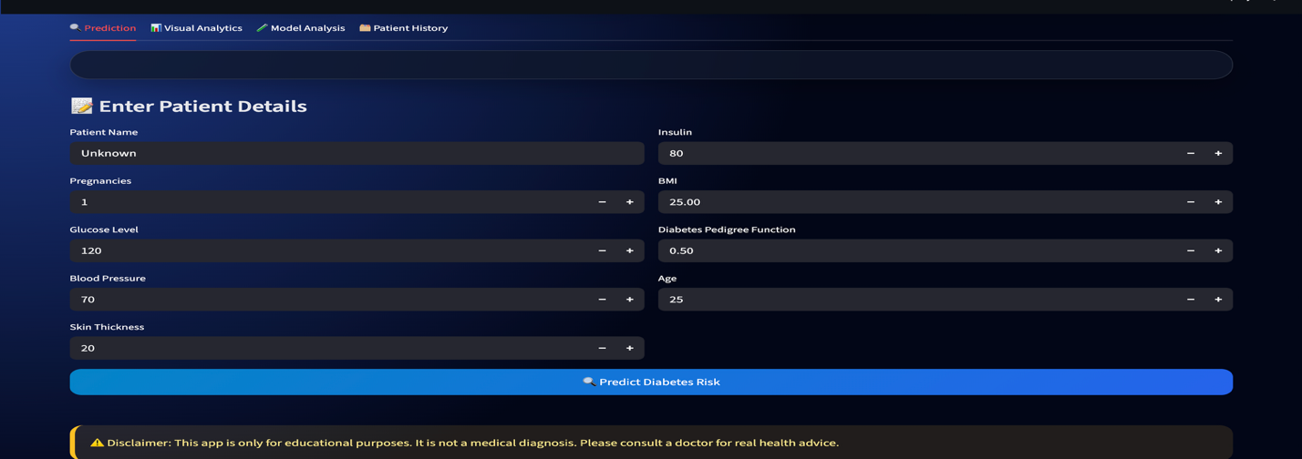

4.4 Health Recommendation System (IMPORTANT FEATURE)
After prediction, the system provides personalized health recommendations based on the risk level.

📌 Logic Used
- High Risk → Immediate doctor consultation + strict precautions
- Medium Risk → Medical checkup + preventive care
- Low Risk → Healthy lifestyle advice

📌 Example Output
- Avoid sugar and junk food
- Exercise regularly
- Monitor blood glucose levels
- Maintain a balanced diet
👉 This feature makes the system more practical and healthcare-oriented.
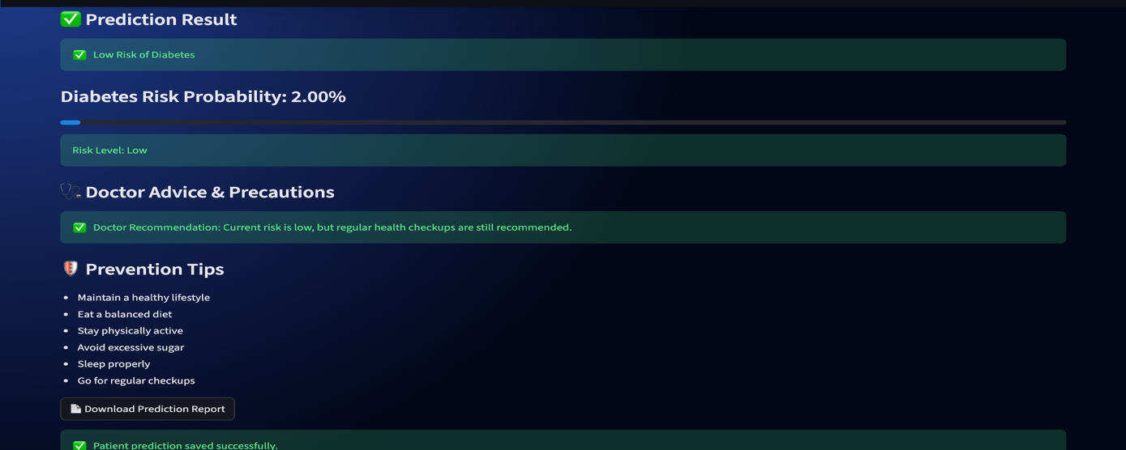

4.5 Data Visualization
The system uses Plotly to generate interactive graphs such as:
- Glucose distribution histogram
- BMI vs Glucose scatter plot
- Correlation heatmap
- Feature importance chart
👉 These visualizations help users understand data patterns and model behavior.

4.6 Model Analysis
Multiple machine learning models are implemented and compared based on accuracy.

📌 Models Used
- Random Forest
- Logistic Regression
- Decision Tree
- KNN
The confusion matrix is used to evaluate model performance.

4.7 AI Assistant Integration
An offline AI assistant is integrated into the system to improve user interaction.

📌 Features
- Answers user queries
- Explains prediction results
- Provides system information
- Includes chat memory
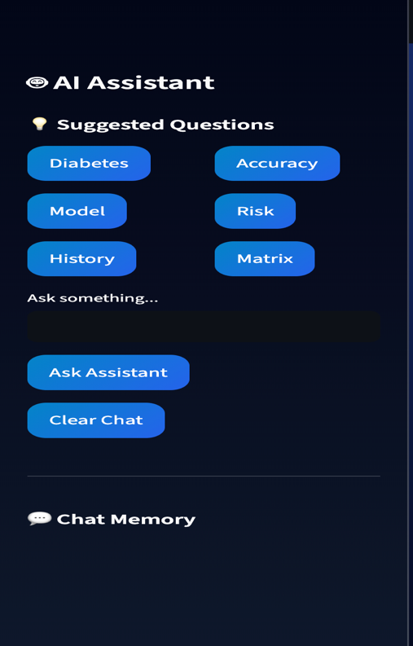

4.8 Patient History Storage
The system stores prediction results in a CSV file for future reference.

📌 Stored Data
- Patient details
- Prediction result
- Risk level
- Probability
This allows tracking of previous predictions.
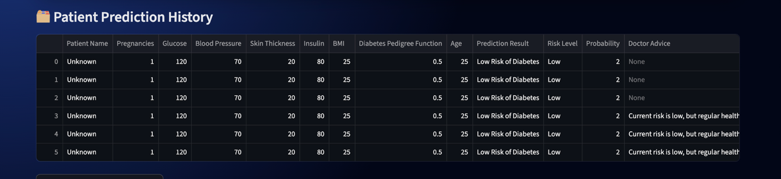

📄 5. Results and Analysis
The performance of the proposed diabetes prediction system is evaluated using multiple machine learning models and visualization techniques. The results demonstrate the effectiveness of the Random Forest algorithm and the usability of the developed system.

5.1 Model Performance
The system compares different machine learning algorithms based on accuracy.

📌 Models Evaluated
- Random Forest
- Logistic Regression
- Decision Tree
- K-Nearest Neighbors (KNN)

📌 Observation
Among all models, Random Forest achieved the highest accuracy (≈72%) and is selected as the final model for prediction.

5.2 Confusion Matrix Analysis
The confusion matrix is used to evaluate classification performance.

📌 Components
- True Positive (TP) – Correctly predicted diabetic cases
- True Negative (TN) – Correctly predicted non-diabetic cases
- False Positive (FP) – Incorrect positive predictions
- False Negative (FN) – Missed diabetic cases

📌 Analysis
The confusion matrix shows that the model performs well in identifying both diabetic and non-diabetic cases, although some misclassifications exist due to overlapping data patterns.
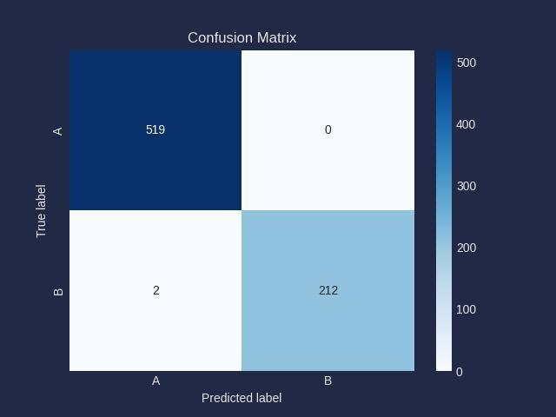

5.3 Visualization Results
The system includes interactive visualizations to understand data patterns:
- Histogram – Shows distribution of glucose levels
- Scatter Plot – Displays relationship between BMI and glucose
- Heatmap – Shows correlation between features
- Feature Importance Graph – Identifies key influencing factors

📌 Observation
Glucose, BMI, and Age are the most significant features affecting diabetes prediction.

5.4 System Performance and Usability
The developed application provides:
- Real-time prediction
- Fast response time
- User-friendly interface
- Interactive dashboard

📌 Observation
The integration of visualization and AI assistant improves user understanding and system usability.

5.5 Health Recommendation Analysis (Your Unique Feature 🔥)
After prediction, the system provides doctor advice and precautionary measures based on risk level.

📌 Output Behavior
- High Risk → Immediate doctor consultation + strict precautions
- Medium Risk → Medical checkup + preventive measures
- Low Risk → Healthy lifestyle suggestions

📌 Observation
This feature enhances the practical value of the system by converting predictions into actionable health guidance.

6. Advantages
- Real-time prediction
- User-friendly dashboard
- Multi-model comparison
- Actionable health advice
- AI assistant support
- Patient history tracking

7. Limitations
- Dependent on dataset quality
- Not a replacement for medical diagnosis
- Limited feature set

8. Future Scope
- Integration with hospital systems
- Mobile application
- Deep learning models
- Online AI chatbot
- Personalized diet plans

9. Conclusion
The proposed system effectively predicts diabetes risk using machine learning and enhances usability through visualization, AI assistance, and doctor/precaution recommendations. It demonstrates the practical role of AI in early disease detection and decision support.

10. References
- UCI Machine Learning Repository – Pima Indians Diabetes Dataset
- Scikit-learn Documentation
- Streamlit Documentation
- Recent studies on ML in healthcare

